Javascript tutorial References

Arrow Functions

Old Javascript

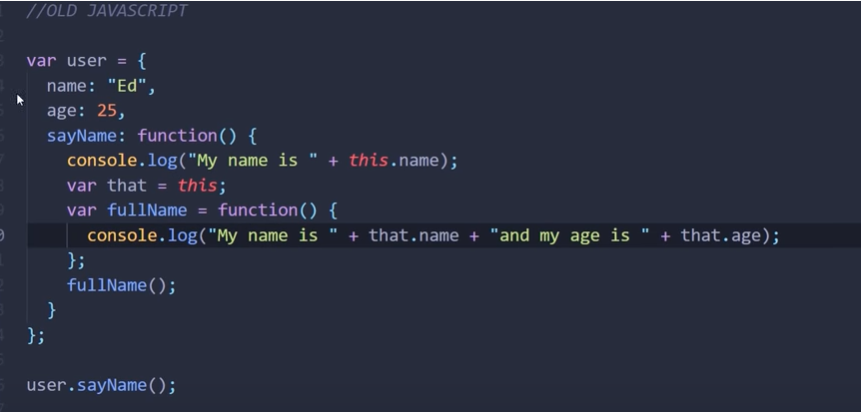

New JavaScript-using arrow function avoid var that =this

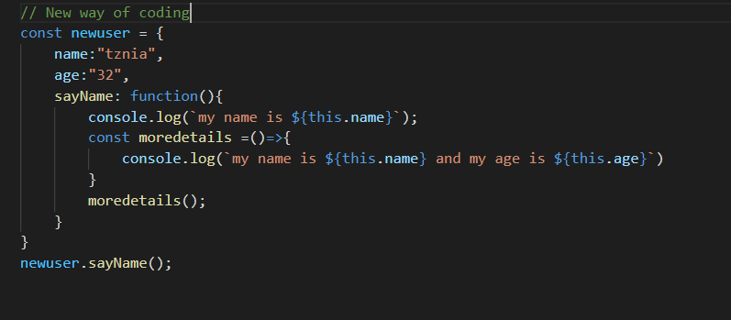

Old Code

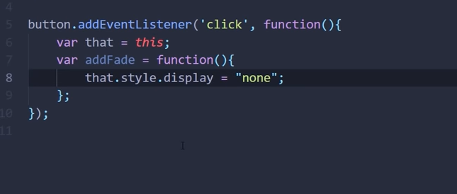

Default Parameters

Old Code

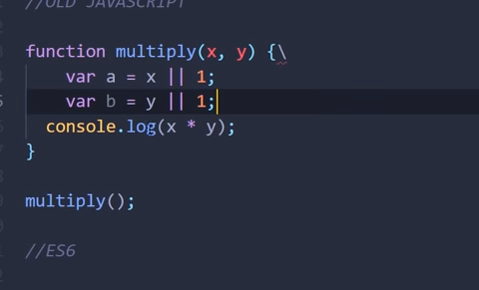

//old js code for defaul parameter

 function Multiply(a,b){

    var c=a||1;

    var d=b||1;

    const cal =`Multiply ${c\*d}`;

    return cal;

  console.log(`Multiply ${c\*d}`);

}

function display(){

    document.getElementById("demo").innerHTML = Multiply(20,20);

}

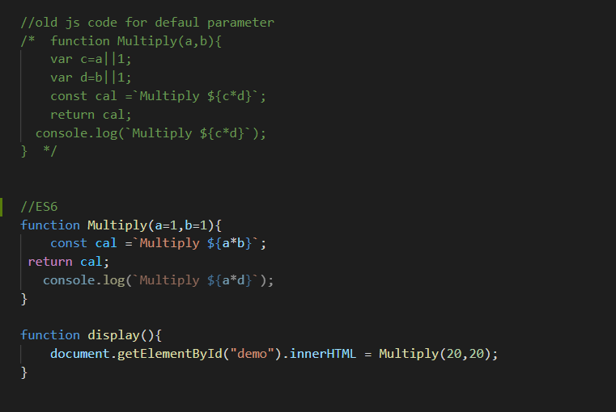

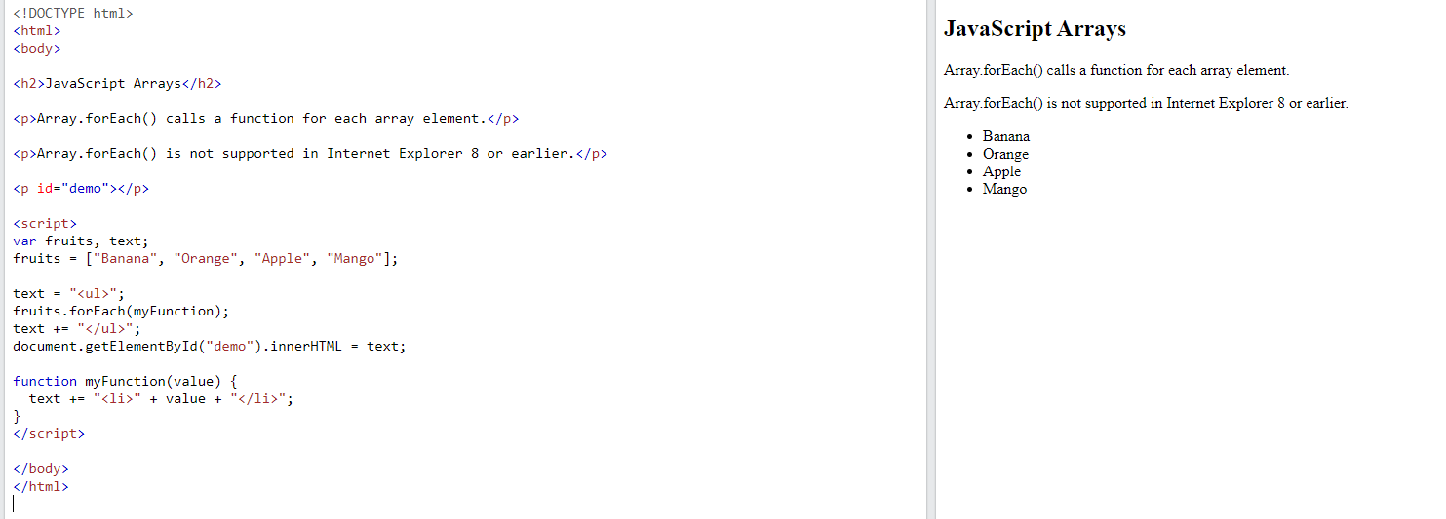

Javascript Arrays with foreach new way

// array accessing with foreach

//old js

const cars = ["Saab", "Volvo", "BMW"];

 cars.forEach(function(product){

    console.log(product)

})

//Es6

cars.forEach((product)=>{ console.log(product)})

Using Map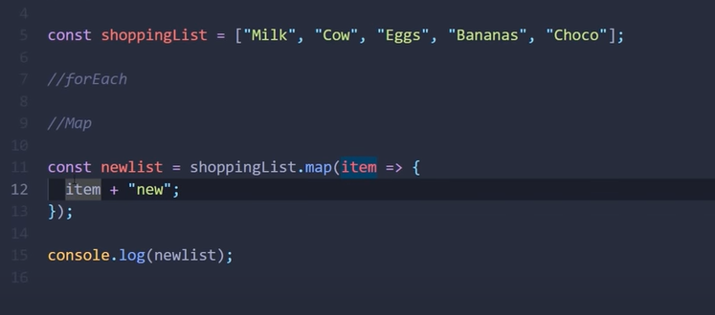

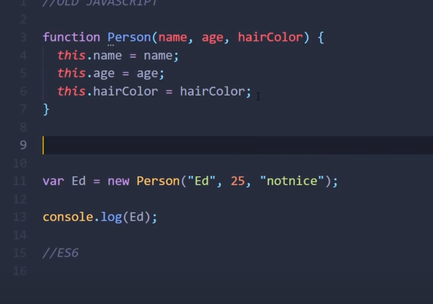

Adding a prototype function

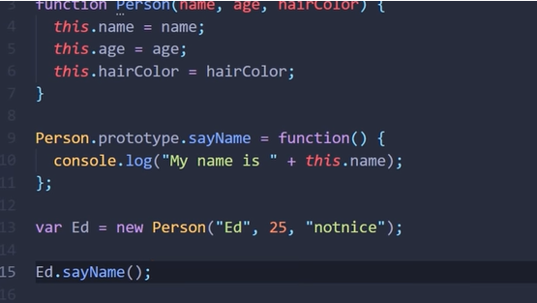  
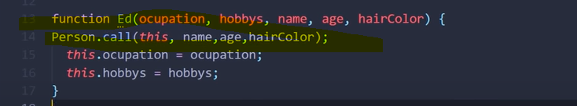

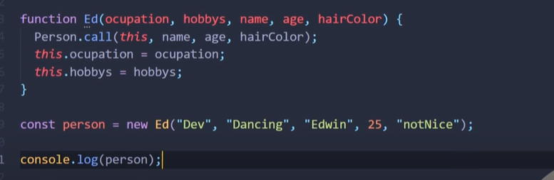



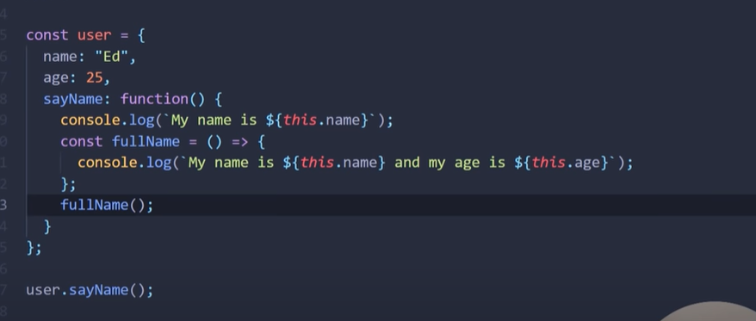

Using classes for the same

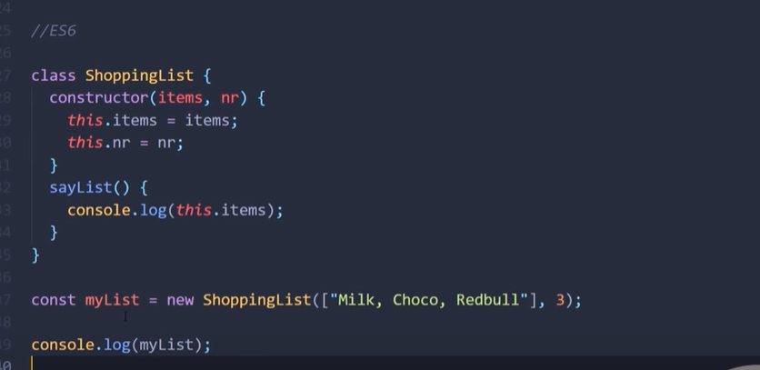 

Extend parent to another class

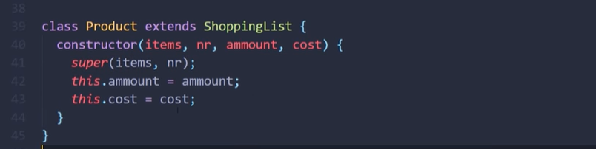  


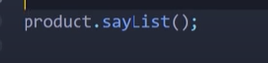will work

Callback Function

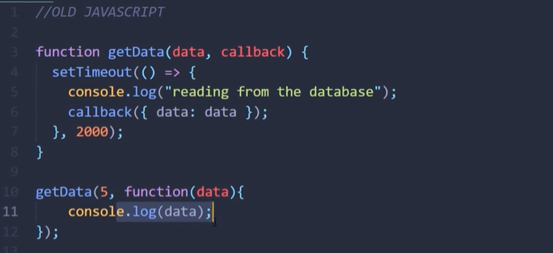

Use promise instead

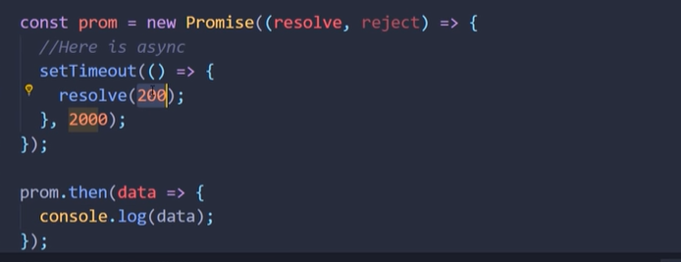

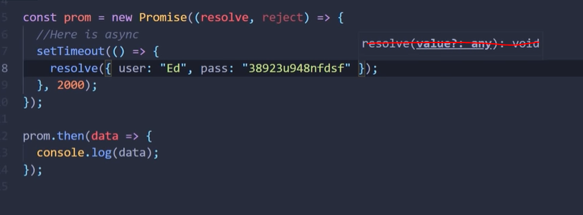

Adding reject error

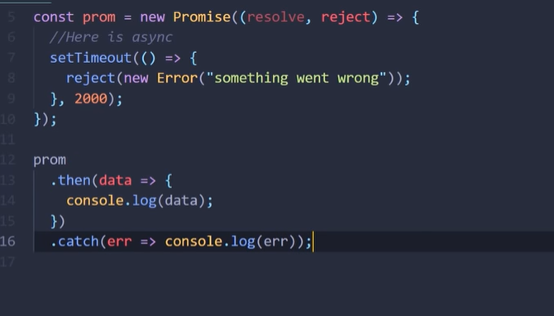

<https://www.reactnativeschool.com/javascript-essentials>

JavaScript Assignment Operators

Assignment operators assign values to JavaScript variables.

|  |  |  |
| --- | --- | --- |
| **Operator** | **Example** | **Same As** |
| = | x = y | x = y |
| += | x += y | x = x + y |
| -= | x -= y | x = x - y |
| \*= | x \*= y | x = x \* y |
| /= | x /= y | x = x / y |
| %= | x %= y | x = x % y |
| \*\*= | x \*\*= y | x = x \*\* y |

The **addition assignment** operator (+=) adds a value to a variable.

Assignment

<https://www.youtube.com/watch?v=8aGhZQkoFbQ>

[**Sandeep Perkari**](https://app.slack.com/team/UBM3M51CL)**:house_with_garden:**  [12:56 PM](https://rsrit-training.slack.com/archives/D024N6A4EDP/p1623175015013200)

<https://www.youtube.com/watch?v=F2DBSH2VoHQ>

white_check_markeyesraised_hands

<https://gitsheet.wtf/>

<https://www.youtube.com/watch?v=WZQc7RUAg18> ES6 Javascript Tutorial For Beginners | ES6 Crash Course

[1:59](https://rsrit-training.slack.com/archives/D024N6A4EDP/p1623178760014000)

<https://www.youtube.com/watch?v=NCwa_xi0Uuc> ES6 Tutorial: Learn Modern JavaScript in 1 Hour

<https://www.youtube.com/watch?v=3dHNOWTI7H8>

ng serve --port 4401